**Part 1: Login to Azure Portal**

1. Open your web browser and go to [Azure Portal](https://portal.azure.com/).
2. Use the credentials provided by Group Leads to sign in.

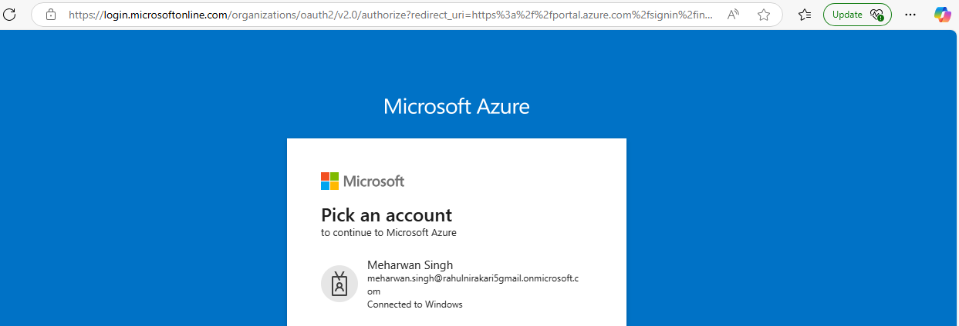

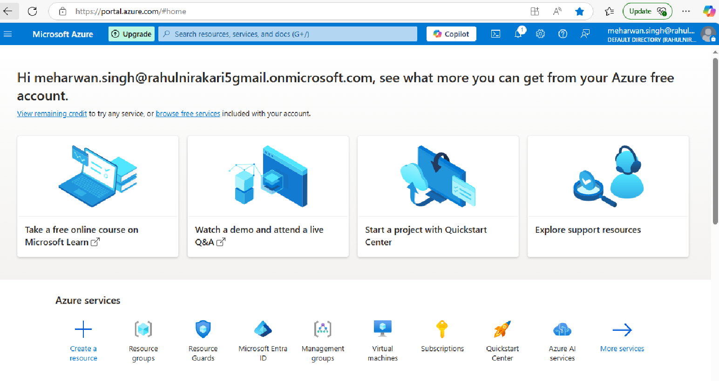

Navigate to Resource Groups

* • In the left-hand menu, click on **"Resource groups"**
* If you don’t see it, search for **"Resource groups"** in the search bar at the top.

•

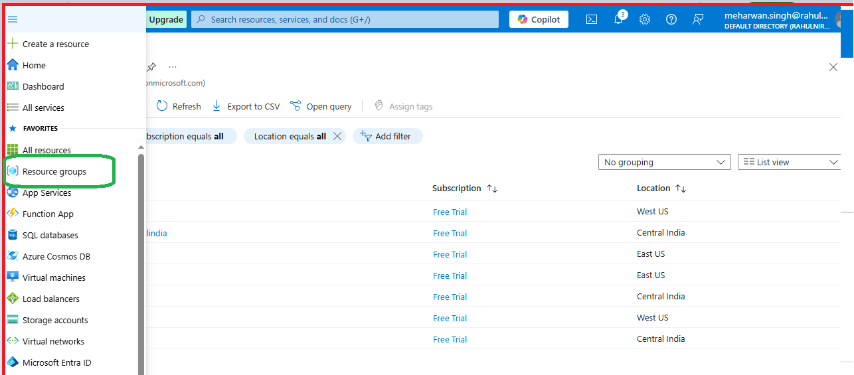

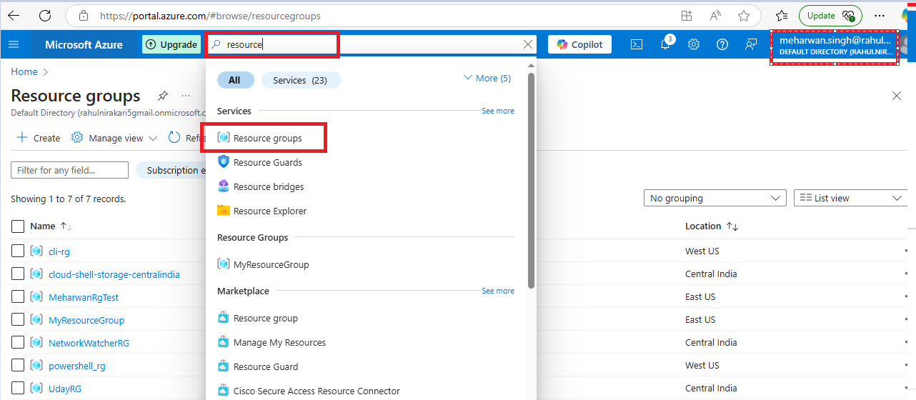

### ****Part 2: Create a Resource Group Using Azure Portal****

**Click on “Create”** button at the top.

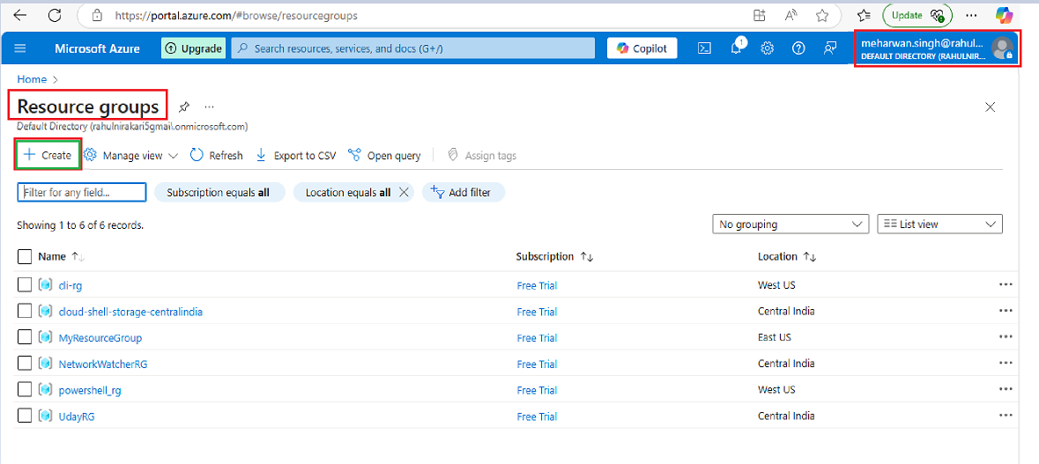

• **Enter Required** following  **Details**

* **Subscription:** Select the Azure subscription to use.as we have free Trial
* **Resource Group Name:** Enter a unique name (e.g., MsrRgTest).
* **Region:** Choose a region (e.g., (Asia Pacific)Central India) where the resources will be hosted.

•

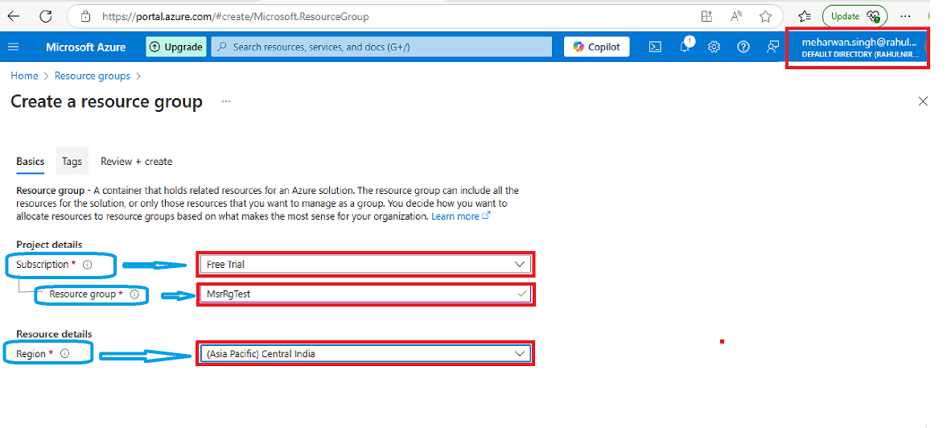

**Review and Create**

* Click **"Review + Create"** to validate your selections.
* Click **"Create"** to deploy the resource group.

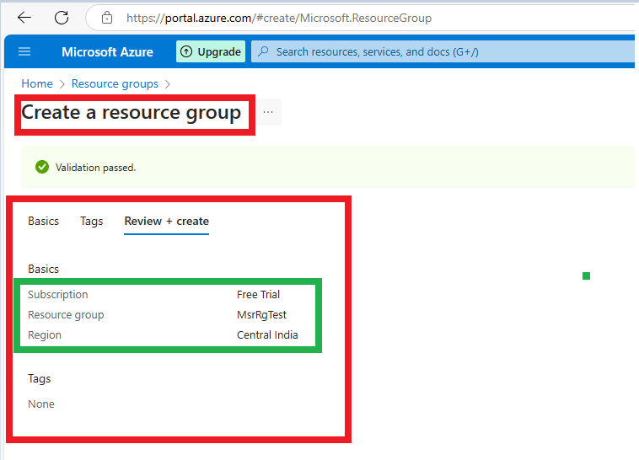

**Verify the Resource Group**

* Once created, go to **"Resource groups"** in the portal.
* Search for your **Resource Group Name** to ensure it's created.

 Refresh the resource group list, select **Refresh** from the top menu. To open the newly created resource group, select it from the list. Or, select **Notification** (the bell icon) from the top, and then select **Go to resource group** to open the newly created resource group.

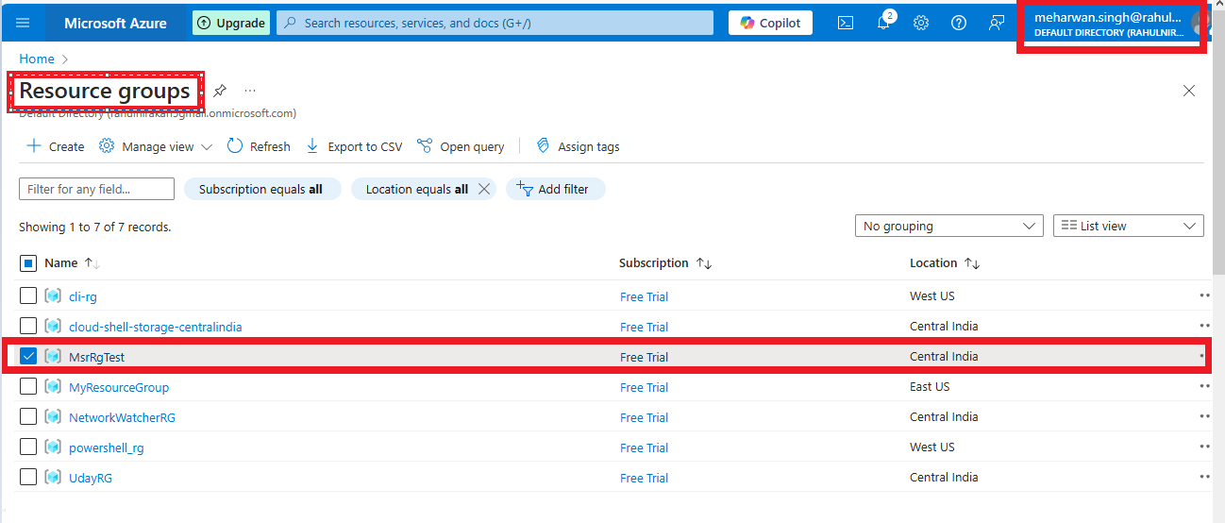

1. **“Delete Resource Group”**

Open the resource group you want to delete.

On the resource group page, click the **“Delete resource group”** button at the top.

1. **Confirm Deletion**
   * A confirmation box will appear.
   * Enter the **resource group name** to confirm.
   * Click **“Delete”** to proceed.
2. **Wait for Deletion**
   * The deletion process may take a few minutes depending on the resources inside the group.
   * Once deleted, it will no longer appear in the resource groups list.

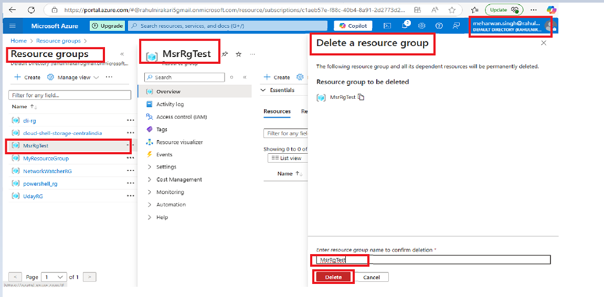

### ****Part 3: Install Azure CLI and Create a Resource Group Using CLI****

Open **Command Prompt (cmd)** or **PowerShell**, then verify the version

az --version:

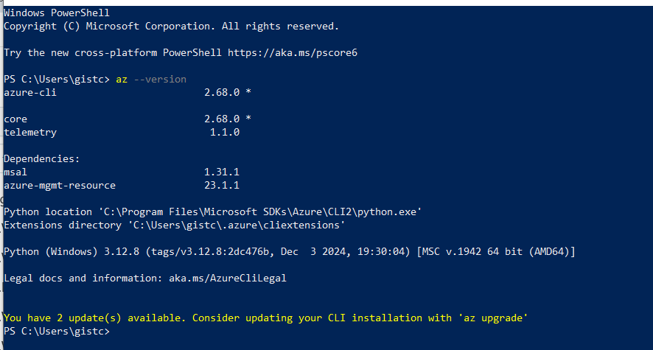

### ****Step 2: Log in to Azure****

Once installed, log in to your Azure account:

az login

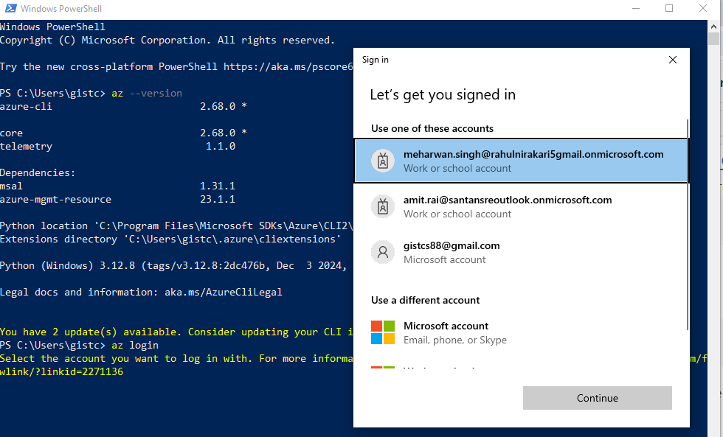

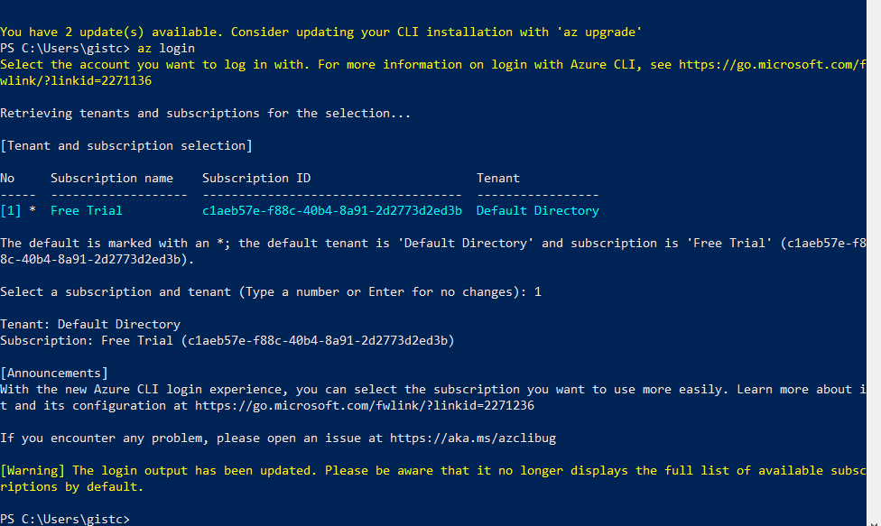

Run the following command to create a new Resource Group named

az group create -n MeharwanRgTest -l eastus

or

az group create --name MeharwanRgTest --location eastus

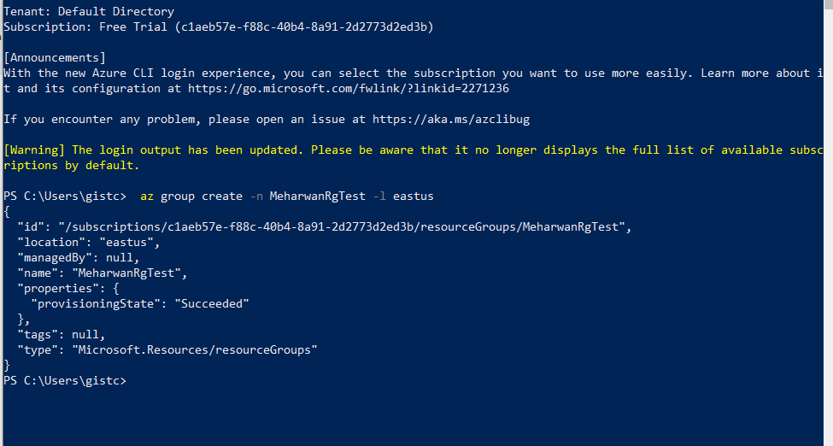

Verify the creation by running

az group list -o table

Or

az group list --output table

